**Problem statement**

**Predicting Coupon Redemption :** XYZ Credit Card company regularly helps it’s merchants understand their data better and take key business decisions accurately by providing machine learning and analytics consulting. ABC is an established Brick & Mortar retailer that frequently conducts marketing campaigns for its diverse product range. As a merchant of XYZ, they have sought XYZ to assist them in their discount marketing process using the power of machine learning. Can you wear the AmExpert hat and help out ABC?

Discount marketing and coupon usage are very widely used promotional techniques to attract new customers and to retain & reinforce loyalty of existing customers. The measurement of a consumer’s propensity towards coupon usage and the prediction of the redemption behaviour are crucial parameters in assessing the effectiveness of a marketing campaign.

ABC’s promotions are shared across various channels including email, notifications, etc. A number of these campaigns include coupon discounts that are offered for a specific product/range of products. The retailer would like the ability to predict whether customers redeem the coupons received across channels, which will enable the retailer’s marketing team to accurately design coupon construct, and develop more precise and targeted marketing strategies.

The data available in this problem contains the following information, including the details of a sample of campaigns and coupons used in previous campaigns -

* User Demographic Details
* Campaign and coupon Details
* Product details
* Previous transactions

Based on previous transaction & performance data from the last 18 campaigns, predict the probability for the next 10 campaigns in the test set for each coupon and customer combination, whether the customer will redeem the coupon or not?

**Approach**

Created a dataset with the right set of features, build models and ensemble them and present as final submission.

**Data**

Below is the schema for the different data tables available.

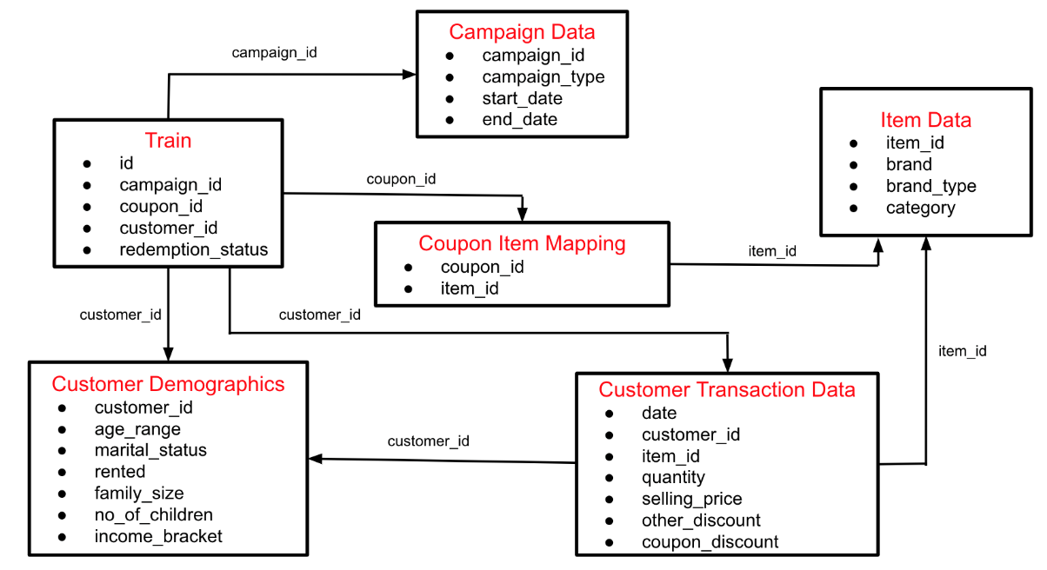

**Data Processing**

* Aim is to predict coupon redemption based on historical customer transaction data.
* Transactions before campaign start date used to avoid leakage.
* Aggregations done are as below:

1. Customer and startdate
2. Coupon and startdate
3. Customer, coupon and startdate
4. Daily aggregates for customer and coupons.
5. Brands and startdate

It is key to remove any leakage to prevent incorrect training data.

**Modelling**

* LightGBM, XGBoost and Catboost were used.
* Mean ensemble of predictions from all models.